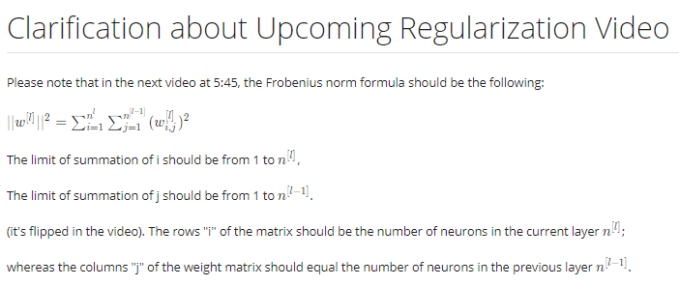

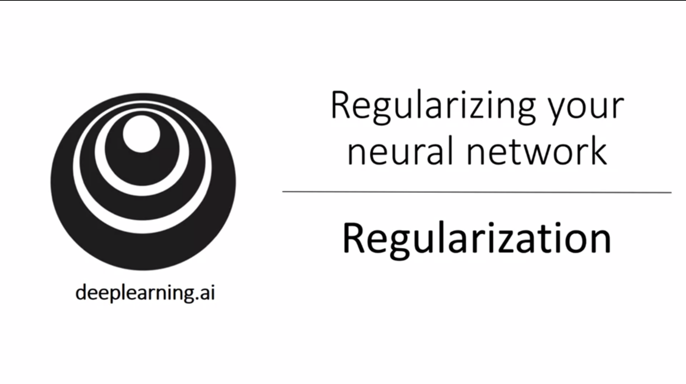

One of the first things to address high variance is regularization (especially when it is not possible to collect more data).

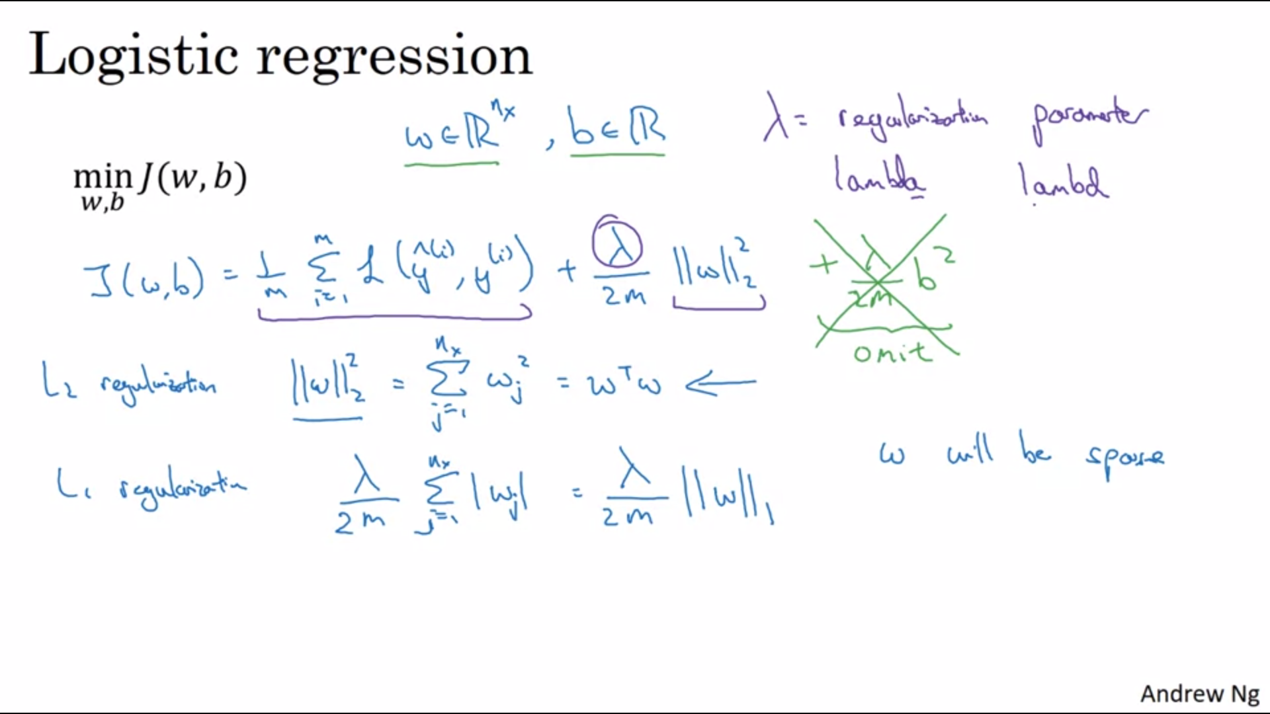

L2 regularization: squared euclidean L2 norm.

B is just omitted in practice because w is much more dimensional and has many more parameters.

L2 regularization is the most common, but L1 regularization does also exist. In that case w will be sparse (a lot of 0s). Some people say this helps to compress the model and reduce memory needs).

Try a variety of values for lambda and tune them with the holdout crossvalidation set. Lamda is a reservey keyword in Python.

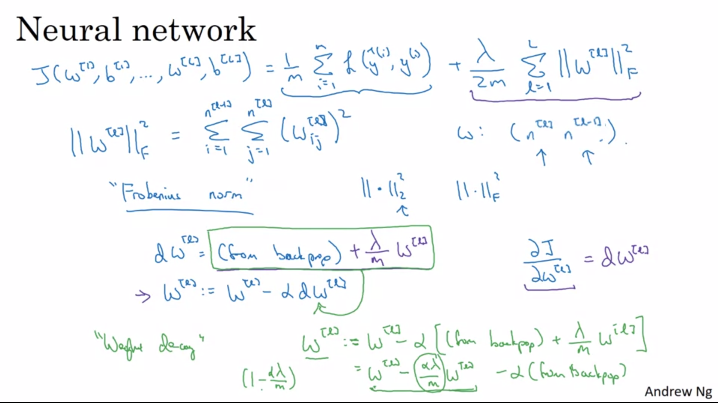

This matrix norm is called frobenius norm and not L2 norm (for arcane linear algebra reasons).

Backprop now has to consider the regularization in the cost function.

L2 regularization is also called weight decay.

The term with the green underline shows that whatever W[l] is you are gonna make it a bit smaller by doing that subtraction.

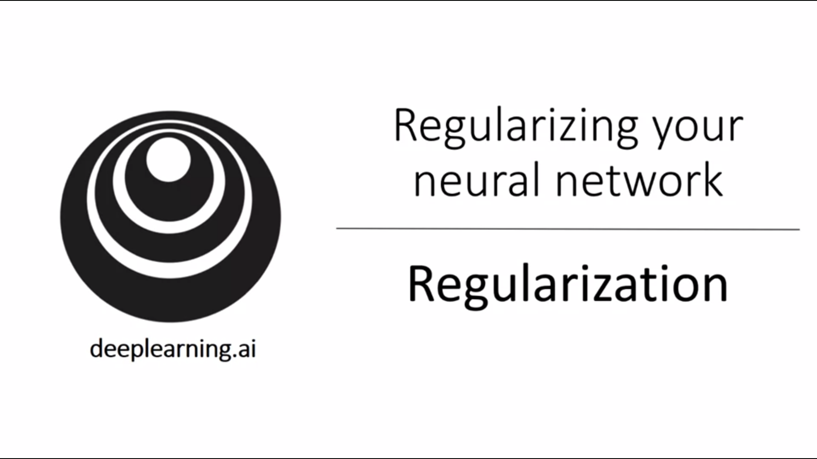

Let’s see some examples how and why it works.

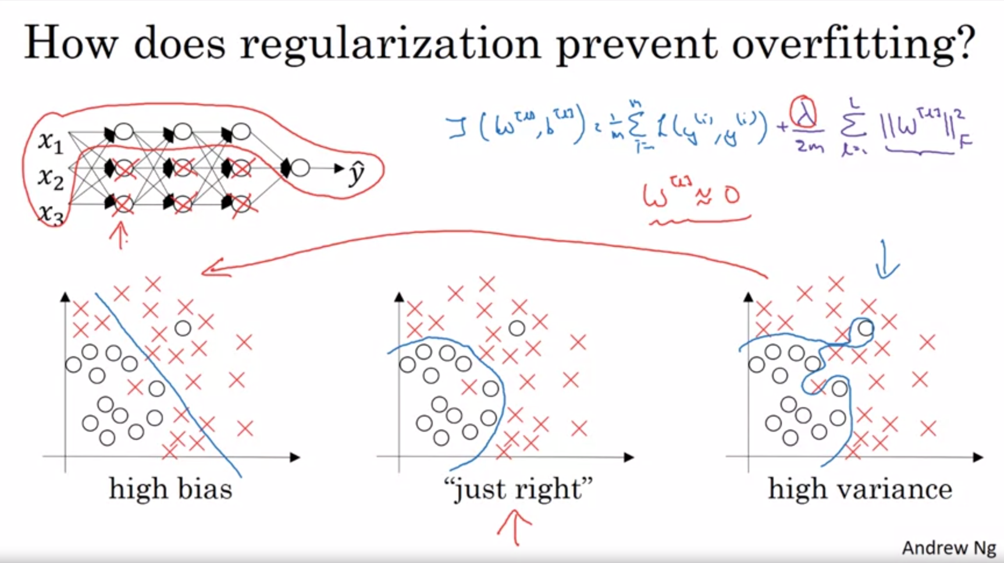

Assume you have a neural network that is currently overfitting. So we add the regularization extra term that penalizes the weights for getting too large.

If lambda is very large, it will set a lot of weights almost to 0 and the neural network will become a much simpler neural network (see crossed out neurons). This may lead to high bias. We want an intermediate lambda that leads us to the case in the middle.

The intuition of completely zeroing out a lot of hidden units is not quite right in practice. What actually happens is that it will still use all the hidden units but a lot of them have just a much smaller effect.

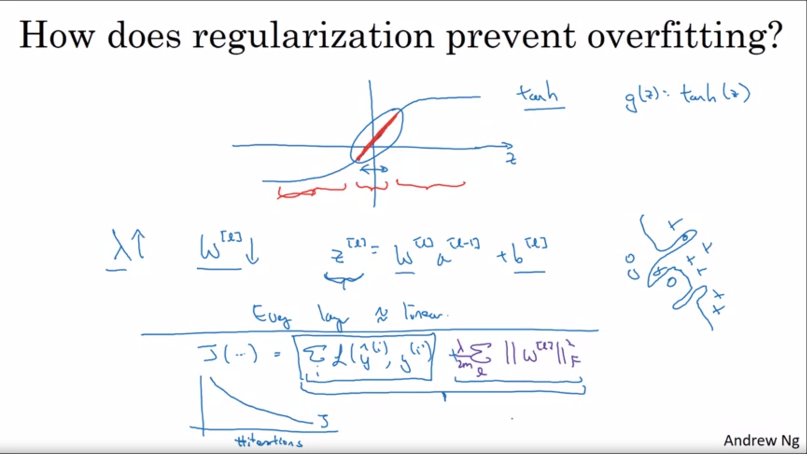

This is another attempt to give additional intuition. Let us assume we are using a tanh activation function. As long as z is very small, we use the linear regime of the tanh activation function.

If lambda is quite high, the parameters are quite small. Then z will also tend to be small and g(z) will be roughly linear (as if it was just linear regression). As we have seen previously, as long as the activations are linear, even a deep neural network can only learn a linear function. So the network will not be able to fit very complex non-linear decision boundaries that allow it to overfit.

One implementational tip is when debugging gradient descent and plotting the cost function over #iterations, we now need to consider the new cost function in order to still see it monotonically decrease on every iteration.

Andrew mostly uses L2 regularization (rather than dropout).

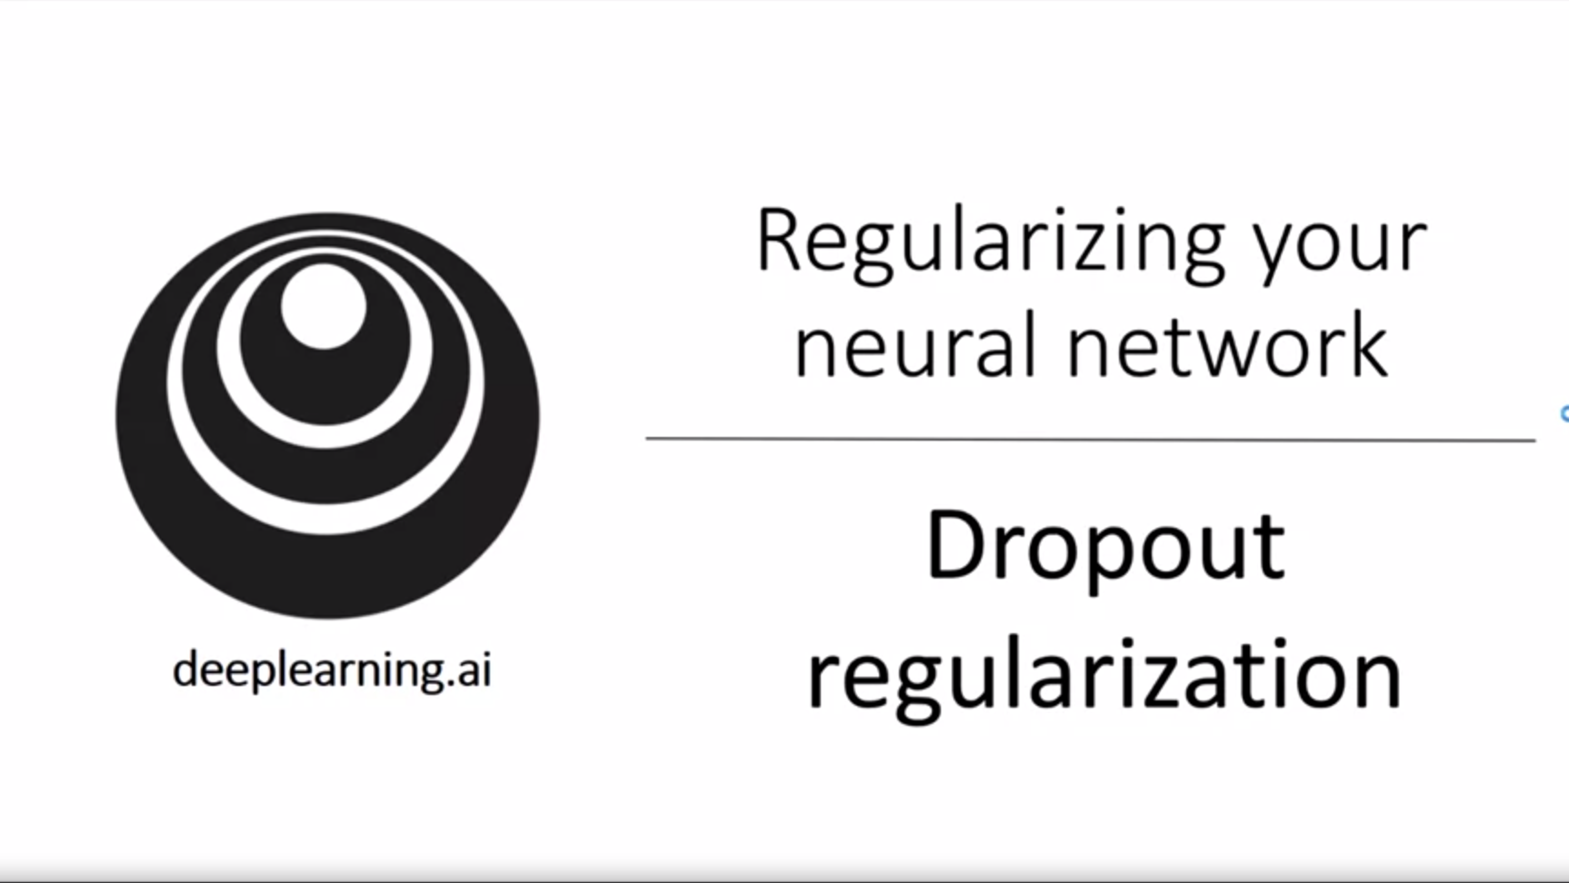

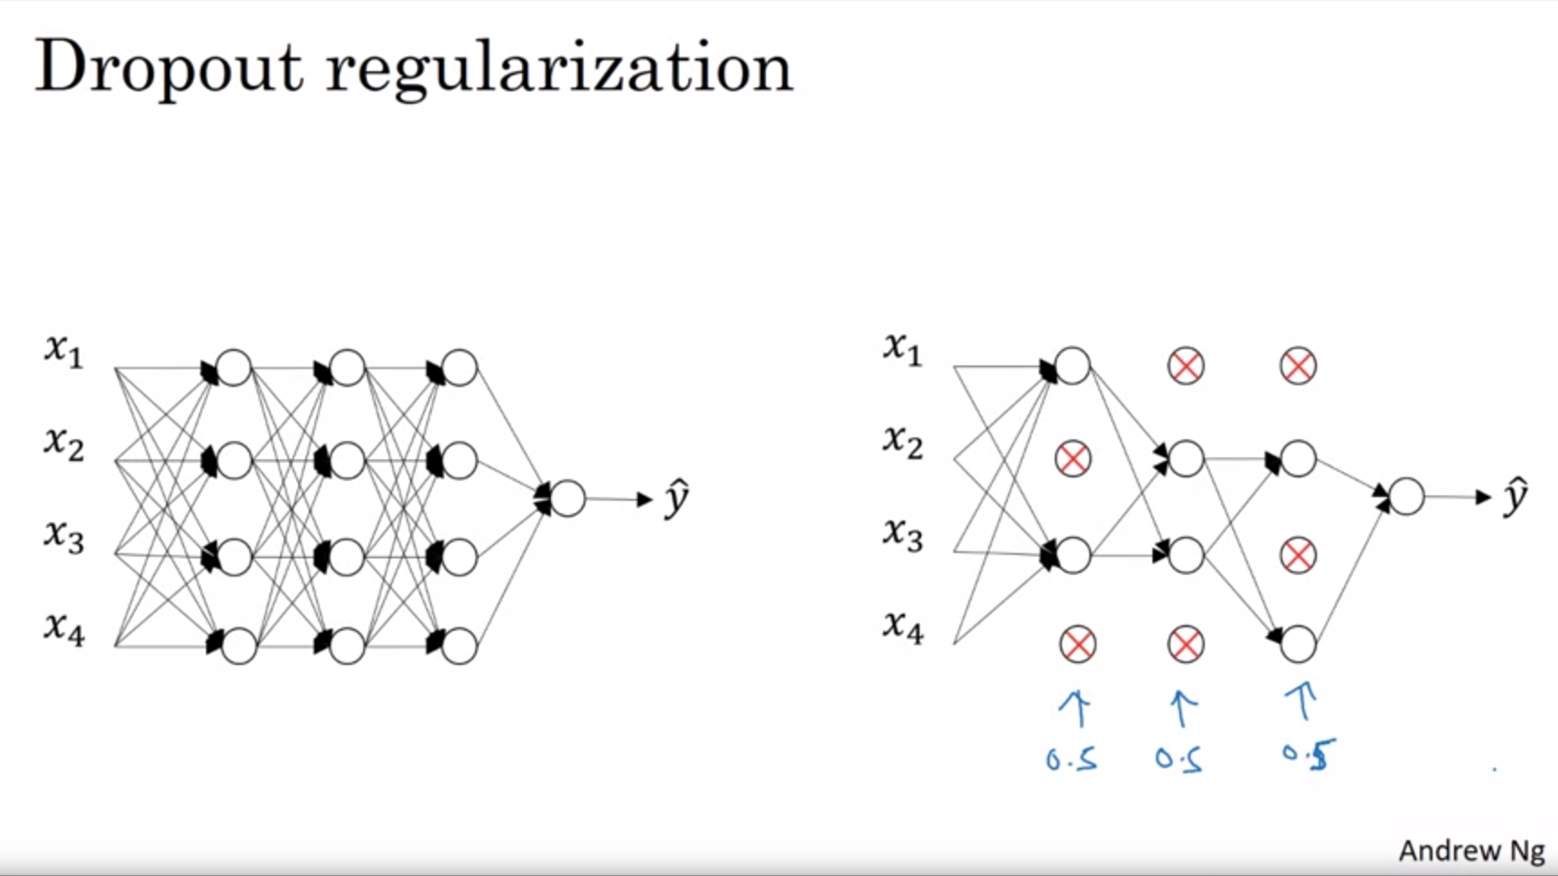

With dropout we go through each of the layers of the network and set some probability to eliminate a node in the network. We will then remove all incoming and outgoing links and do training on the diminished network. This will be done for each training example so that backprop then only considers the nodes that have not been eliminated. On a different training example you would do the same process but come up with a different set of eliminated nodes.

Seems like a slightly crazy technique but this actually works.

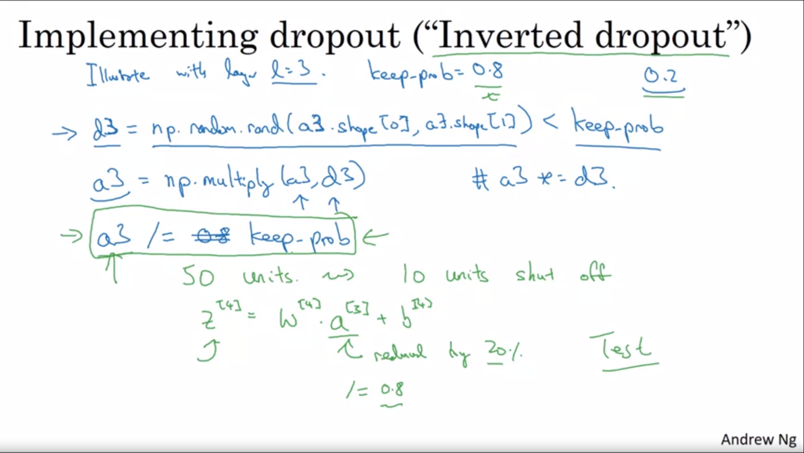

Inverted dropout is the most common technique (there are other ones).

80% chance that an entry in d3 will be 1 and 20% chance it will be 0.

We do element-wise multiplication of a3 with d3. This operation will 0 out corresponding elements.

Finally we scale up a3 by the keep_prob parameter. In green is an example. On expectation a3 will be reduced by 20%. In order to not decrease the expected value we will divide by 0.8. This is the inverted dropout technique: No matter what keep_prob is, it is ensured that the expected value of a[3] stays the same. It turns out that this makes test time easier as you do not have a scaling problem.

On every iteration you 0 out different units for each training example. So this is not constant for one training example over #iterations.

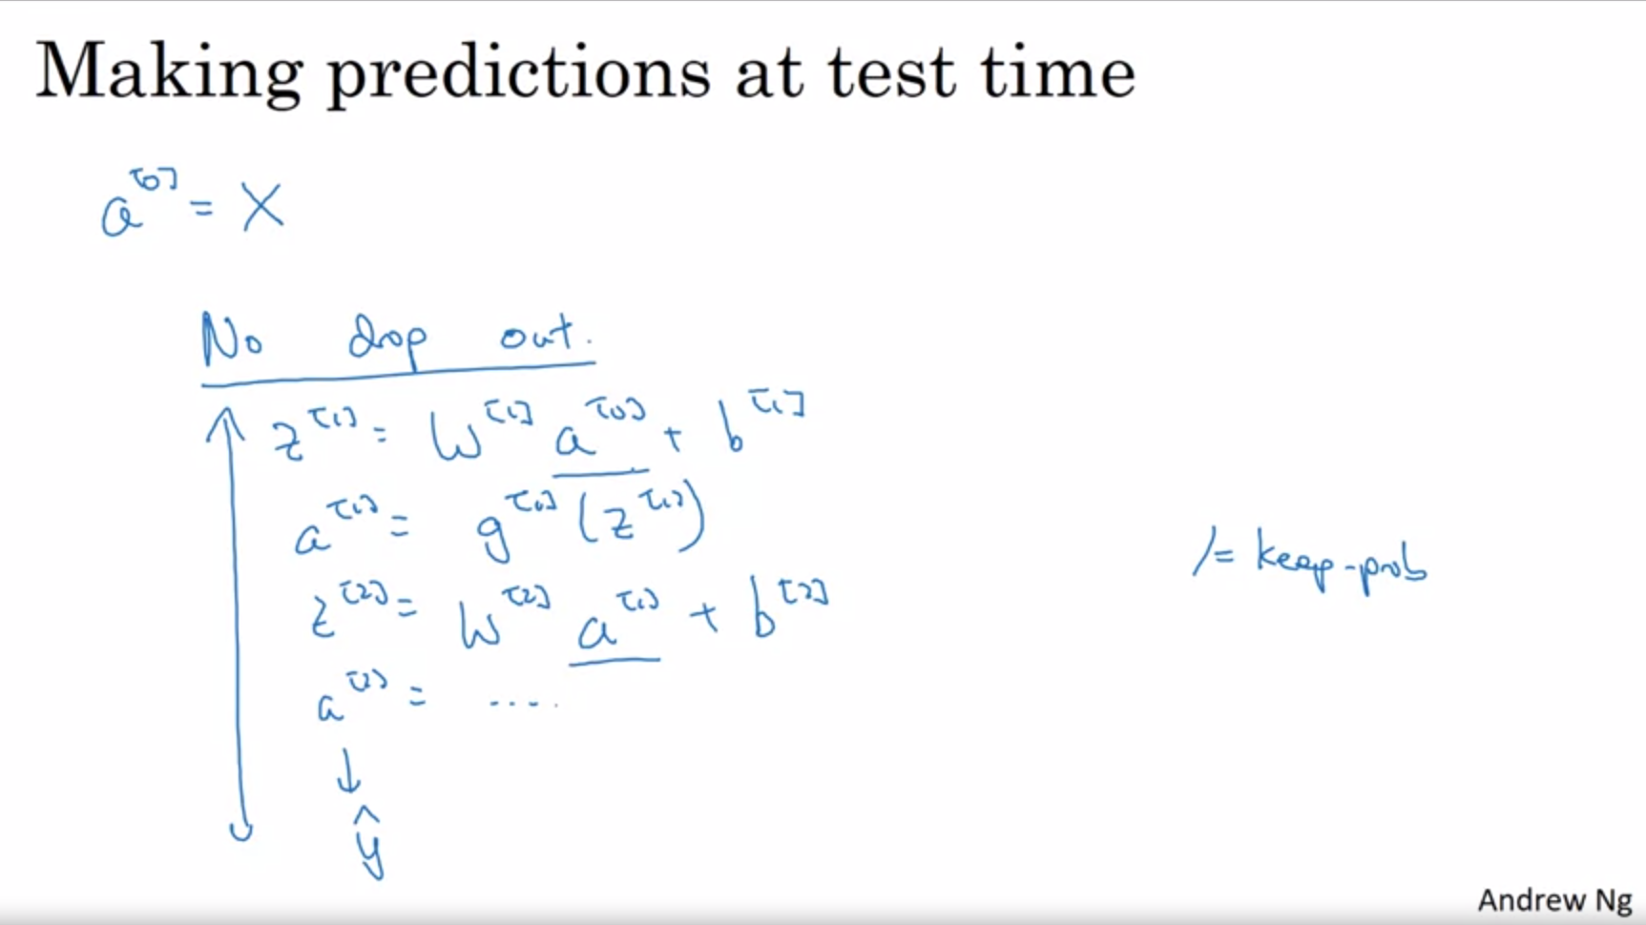

This is what you would do at test time: no drop out. We do not want the output to be random. This would just add noise to the predictions. This is why we did the scaling during training time. So now we do not need to add any parameter to account for that.

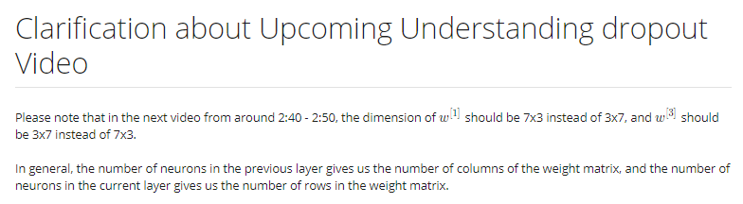

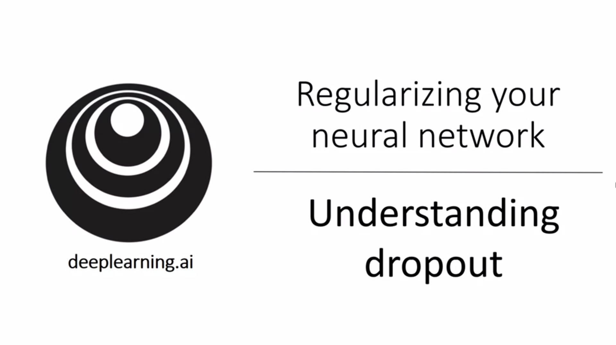

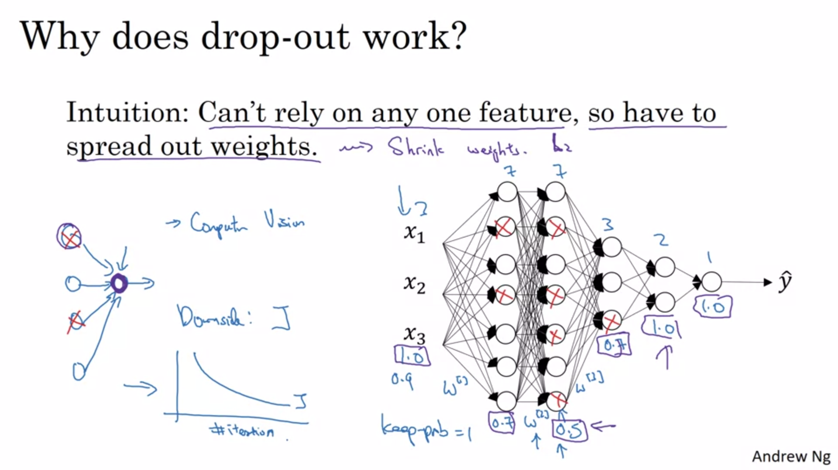

This is a second intuition from the perspective of an individual unit. One unit cannot rely on any feature because they could go away randomly. Similar to L2 regularization this will shrink the weights. Formally dropout can be shown to be an adaptation of L2 regularization but the L2 penalty on different weights are different. So it is possible to show that they have a similar effect.

W[2] will be the largest matrix here with 7x7. Keep_prob can be different across layers. Maybe for this layer you want to have a small value to avoid overfitting. For later layers high values might be more reasonable.

Technically dropout can also be applied to the input layer but in practice this is not done often.

The downside of different keep_probs is that you have even more hyperparameters to search for. The alternative would be to have some layers where you apply dropout and some layers where you just do not apply it.

Many of the first successful applications were in computer vision. This is because so much data is needed that you almost always overfit. Some reserachers / practitioners just add dropout by default. Andrew would suggest to only use dropout when bothered with overfitting. This does not generalize to other applications.

One major downside of dropout is that the cost function is not well defined anymore. It is hard to double check gradient descent then. You lose the debugging tool of looking at the cost function.

Andrew usually turns off dropout and makes sure that J is monotonically decreasing and only then adds dropout and hopes that the implementation is correct.

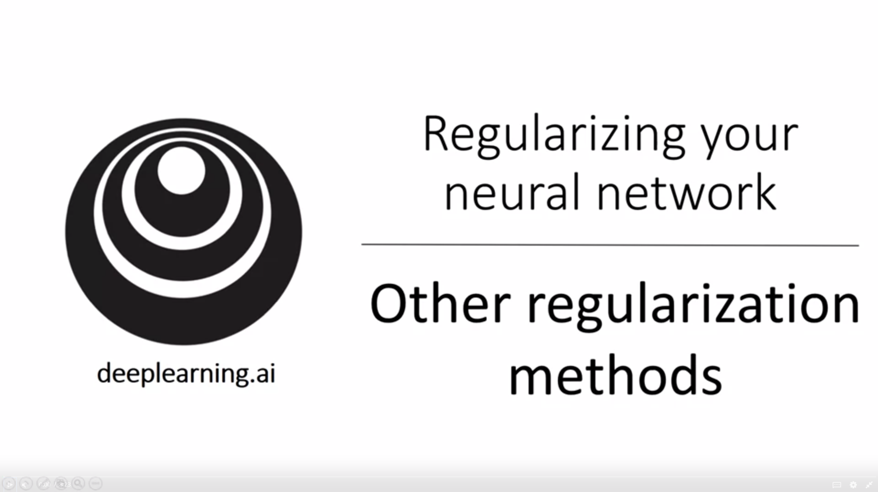

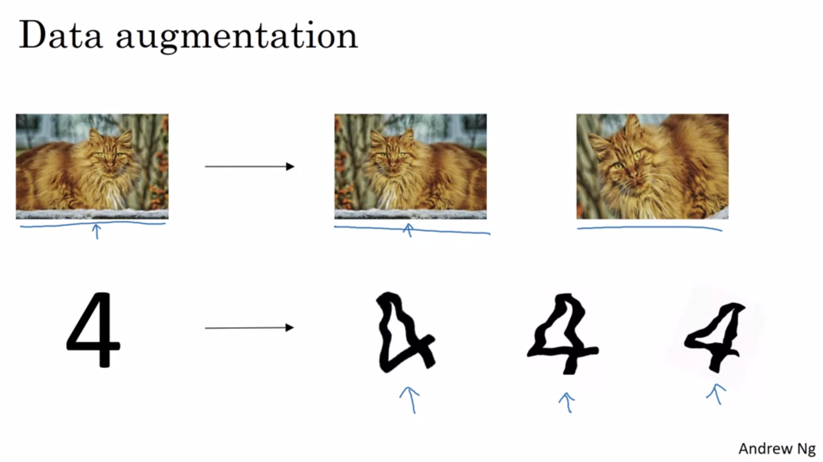

Getting more training data helps but can be expensive. We can flip the image horizontally or vertically for example. This is not as good as independent examples but it is much cheaper. We can also take random crops and zoom ins (or distortions). Again, these synthesized examples do not add as much information as new examples but are almost free except for a bit of computational cost.

For OCR we can impose random rotations and distortions. In practice this can be more subtle than in this example here.

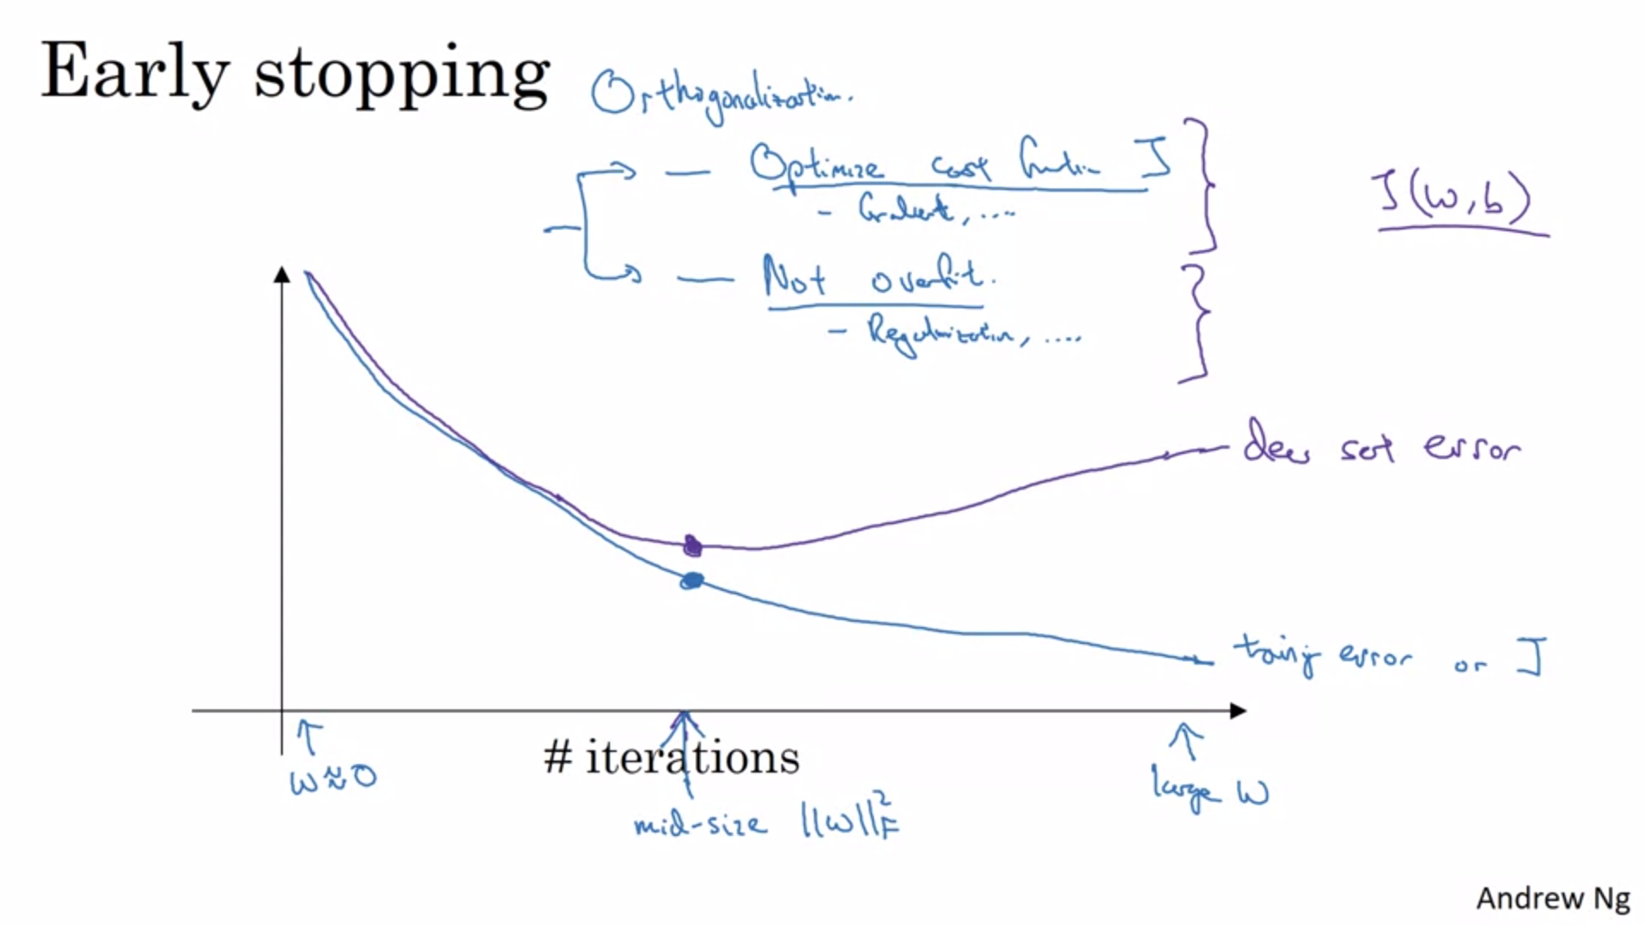

Plot training error or cost function as you run gradient descent. This should decrease monotonically. You will also plot the dev set error (e.g. logistic loss). Early stopping detects where the neural network was doing best and then just stops the training process (e.g. halfway through).

We initialize w’s to small random values so before we train for a long time the w’s will still be rather small. As we iterate, w gets bigger. By stopping halfway we only have a midsize w similar to L2 regularization.

Andrew sometimes uses early stopping but it has one downside. It is better to have one set of tools to optimize the cost function and another set of tools to not overfit. So there are two separate tasks (principle of orthogonalization): we want to think about one thing at a time. Early stopping couples these two tasks so you cannot work on them independently anymore. This makes the things to try more complicated.

Andrew rather trains the model as long as possible using L2 regularization.

The advantage of early stopping is that by just running gradient descent once you can see different w’s without trying a lot of different regularization parameters lambda.

Many people use early stopping.